



Name: SYED MUBEEN

Name: OWAIS AMEEN

Name: ALI RAZA

**Faculty**: **SIR ALI HAIDER**

 **­­**

**February 15, 2022**

**Aptech computer education**

**METRO STAR GATE**

Project Certification

This is to certify that.

SYED MUBEEN (1278713)

OWAIS AMEEN (1282486)

ALI RAZA(1280134)

Has successfully designed & developed

**Calligraphy.**



Date of Submission: 15h FEB 2021.

**INTRODUCTION**

Online **Art Gallery is** an online application, which is used to display and sell art works of artist irrespective of their nationality, gender and other narrow consideration, through auction. Artist can register online for being a member in the art gallery and each artist can upload the digital copy of their art work under the respective categories. They can host their art work either for auction or for fixed price. The artist is liable to pay a fraction of the price of each art work to the web site to find the running fund for site. Art lovers have to go to the art exhibition to collect their favorite arts or painting. But now-a-days they are not getting enough time to go to the galleries and collect the arts and paintings.

**Existing System:**

Customer can also register online and they can browse art works that are arranged in different categories scientifically. Each Customer can create their own gallery to see his favorite art works without much difficult. And each user has the right to purchase an art work using the integrated payment gateway and participate in auction by submitting their bids. Qualified bidder should remit the amount using payment gateway and after each valid payment the art work will be shipped within some days.

**Proposed System**:

ONLINE ART GALLERY is application software and it is very helpful for the art lovers and others who wants to know the addresses where this kind of arts will we sold. This application helps the end-users to search their arts and paintings and they can place order for the selected pieces. The end-user can also get the information about the art exhibition and the respective address, so, that they can visit to those exhibitions.

Art Gallery brings you an opportunity to view online art exhibitions at [Online Art Gallery.](http://www.paletteartgallery.com/contact-palette-art-gallery-india.asp)  We bring you details of all art exhibitions held in the past and the forthcoming show. The Online Art Gallery is updated daily, so the user can view and buy the latest collection of contemporary art online from anywhere in the world. You can view and buy the latest Indian contemporary art collection available at their exhibitions and also at their online gallery.

**SYSTEM DESCRIPTION OF ONLINE GALLERY ART SYSTEM**

Online Art gallery management system is an application that allows buyers to purchase paintings, scriptures, models online. The purchase is just a click away, you don’t have to go to some old museums and buy from selected stuff.

This application will provide us with a wide range of choices. The registration in this application is free

It provides free home delivery to buyers. It allows users to create their own portfolio.

The main menu will contain six parts which are as follow:

* Customer Login
* Admin login
* Art in sale
* New art
* Payment Mode
* About Us
* Contact us

Some key features of the system which is as follow:

* To reduce the hectic of maintaining the record of inventories
* To reduce the cumbersome job of maintaining several documents
* It will eliminate the delays in the generation of reports that which item has sold to whom.
* Searching will become more efficient and fast.
* It will also provide assurance to the customer that they can buy the art they like there would be no pressure.
* Overall it will reduce the cost and time of the customer.

Functional requirements specification:

1. **ADMIN:**

* Admin will use this application to give the access to the customers who want to become the member of the art gallery;
* Admin will add new information regarding the statue and paintings so that the user can easily access it and make his mindset according to that.
* Whenever you want to purchase some paintings or monuments from the gallery you just need to send the request to the admin and he will approve your request if he finds any new painting which you have never seen before.
* In this way, the admin will take care of the persons who want to purchase the paintings or even sell it.

1. **CUSTOMER LOGIN:**

* This option of the website will help the user to get a login and create his profile so that he can access new paintings and check the notifications if there is any new notification regarding new sculpture or Art so that he can bid for that or directly purchase that according to the procedure which has followed by galleries.
* In this part, user can also upload his data related to its personal information such as name, sex, age and his interest related to paintings which is one of the important parts.
* User login consists of two modules:
* You can review the things and rate them according to that you can also purchase the things.
* The user can also request to admin to keep his art in the exhibition for sale so if anyone finds paintings interesting then he/she can contact you.

### PAYMENT MODULE OF ONLINE GALLERY ART SYSTEM:

* This section of the module helps in making the financial transactions so that user can pay it easily.
* Simply we can deposit our money online through an application where you find different options to pay the money options such as pay by debit card, credit card or through net banking.
* user  will get the notification if there is any pending amount, prior two to three days so that clients can deposit it without any late charges.

1. **ABOUT US**

* This feature will provide the information about the company and developers so that if you want to get a new design or any kind of change and suggestion.

1. **CONTACT US**



**Authorized Sign by**

Sir Ali Haider

Home Page

Home Page have some sections like Slider, New Arts , Category wise Arts, and Exhibitions

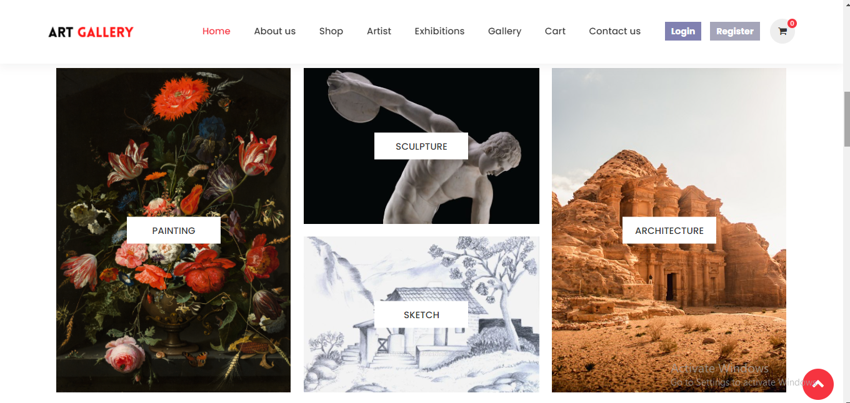

Shop Page

Shop Page have some Filter like, Searching, Category Wise Arts, Sort By,

Filter by Price,Pagination All Filters working with ajax no page reload

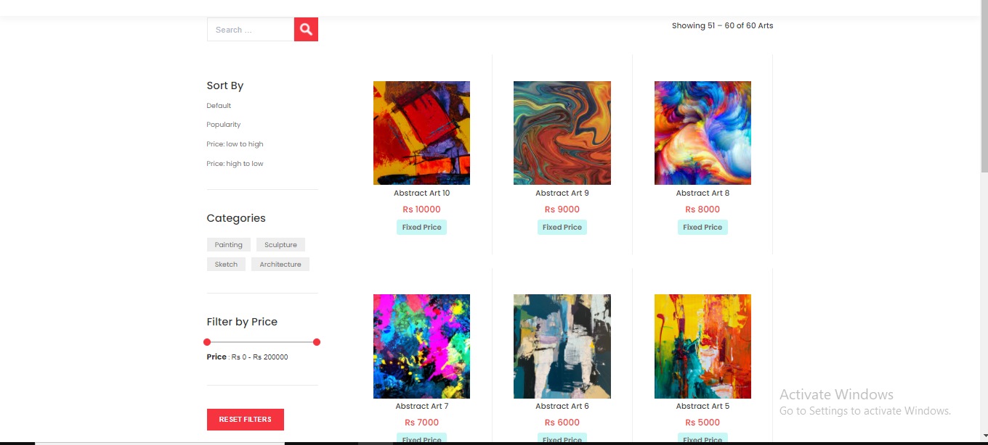

Artist Page

Artist Page add Load More functionality and searching with ajax

And I am click the artist and then show the all art related to artist

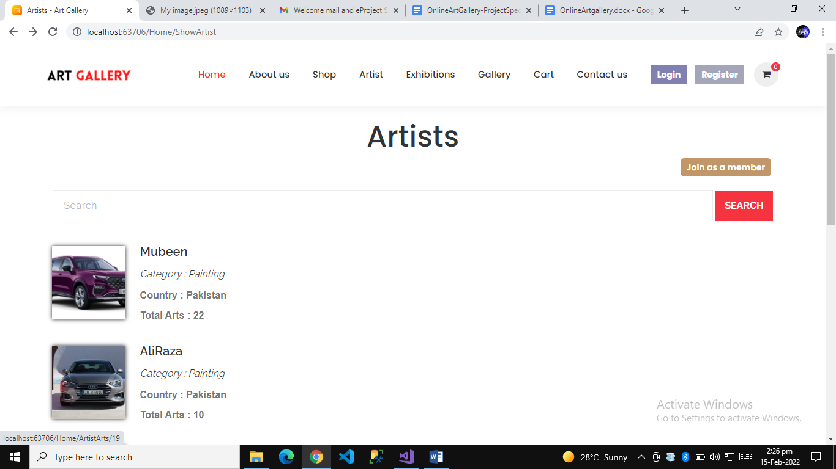

Exhibition Page

I am click the exhibition to show some art related to exhibition

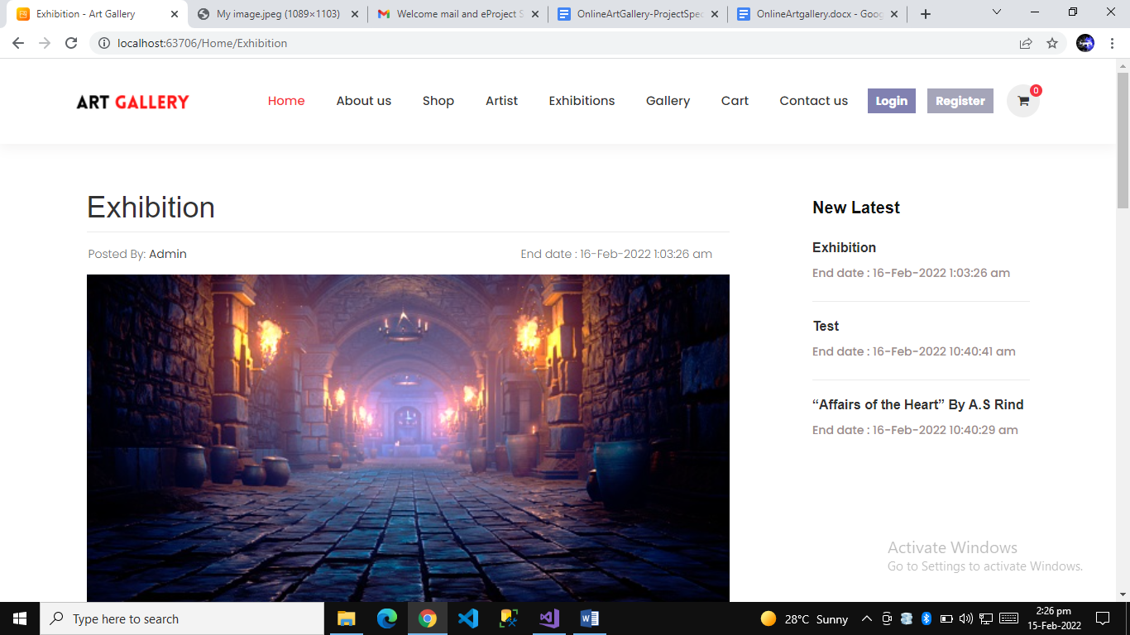

Gallery Page

Customer can create your own gallery with easy method

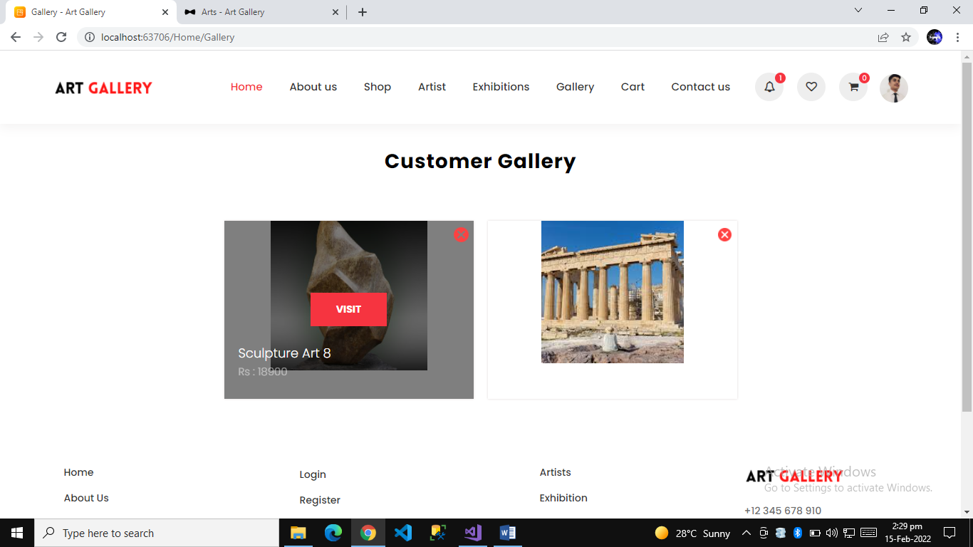

Cart Page

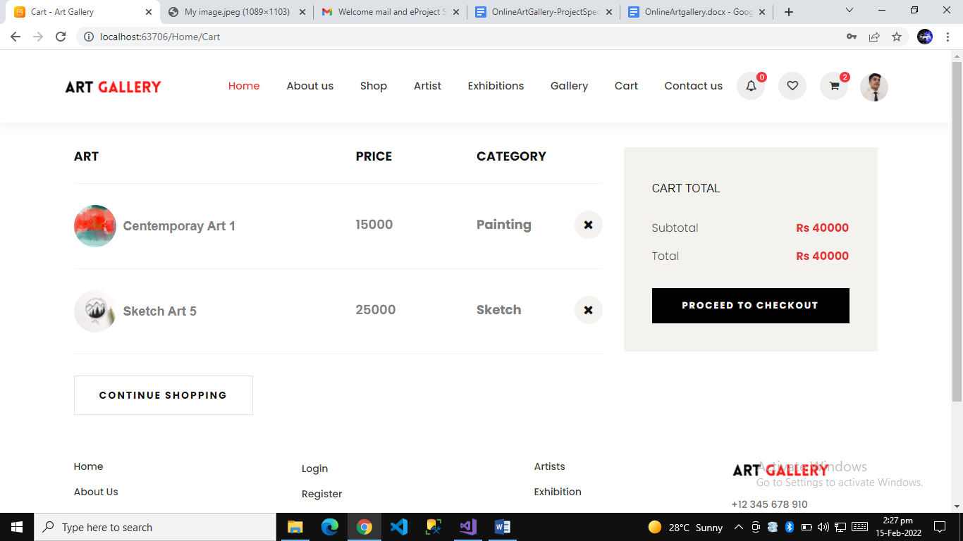

Checkout Page

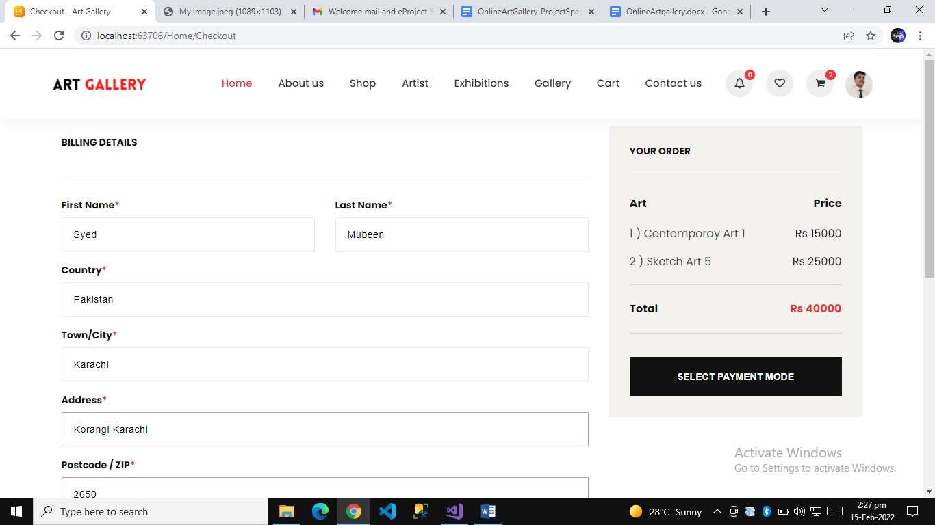

Contact us Page

Customer can create your own gallery with easy method

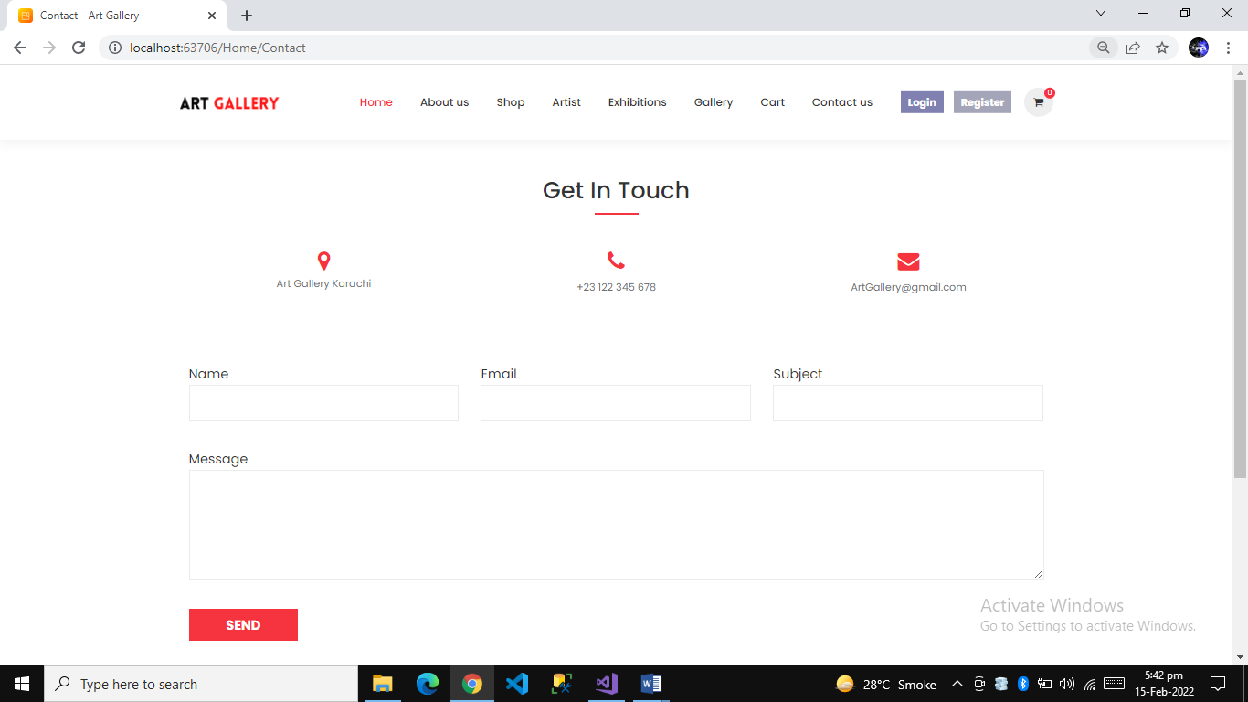

Login Form

Login with Authorize filter

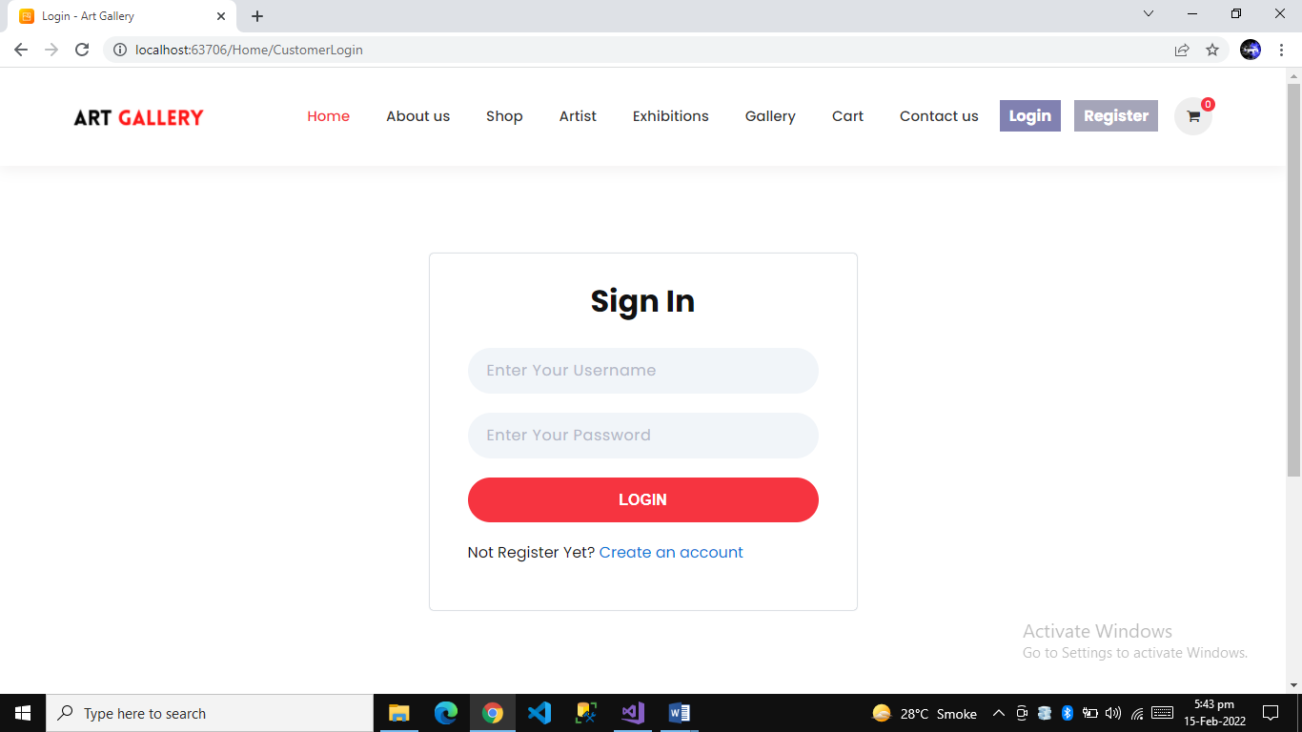

Sign Up Form

Signup with unique username check

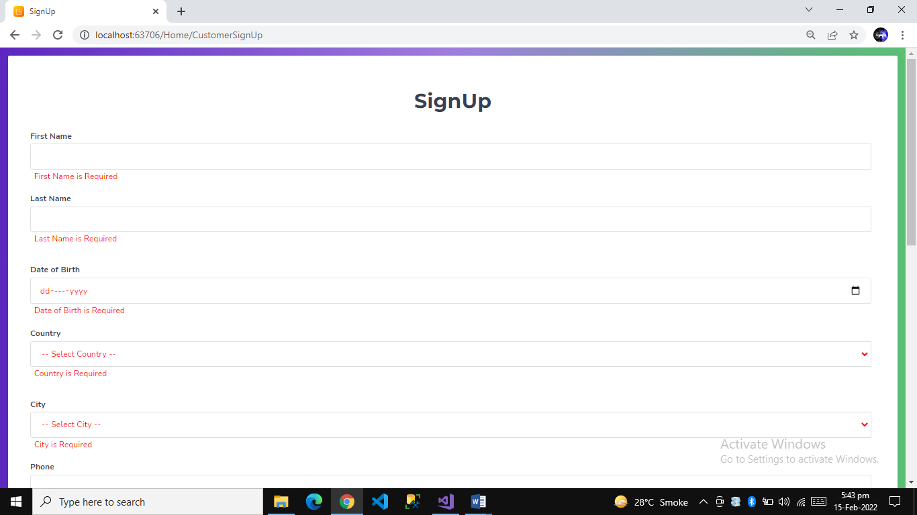

Fixed Price Art Page

Fixed price art page with art to cart functatinality and comments

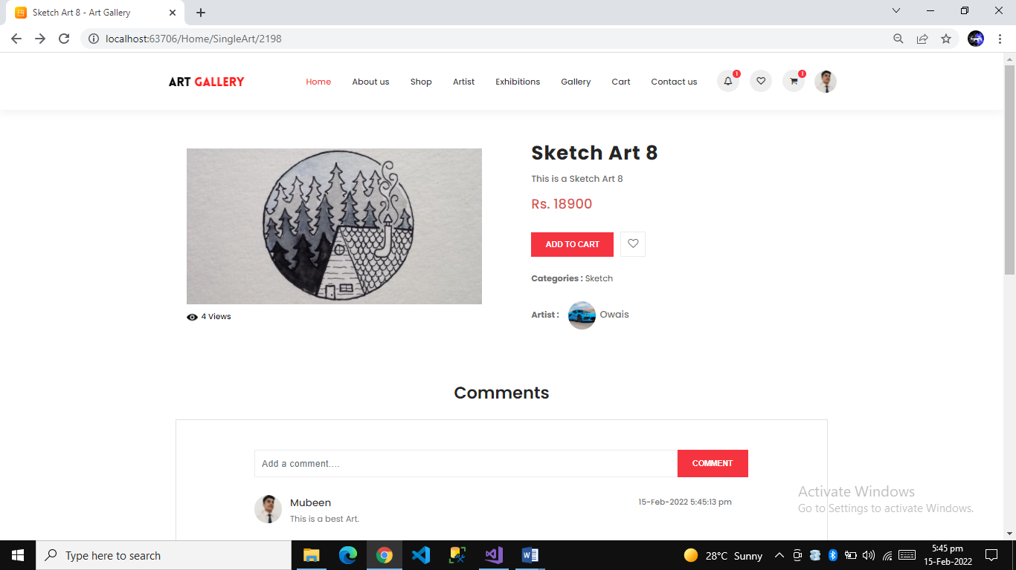

Fixed Price page Code Images Controller Work

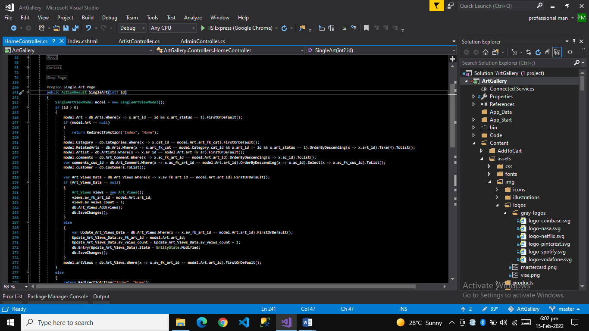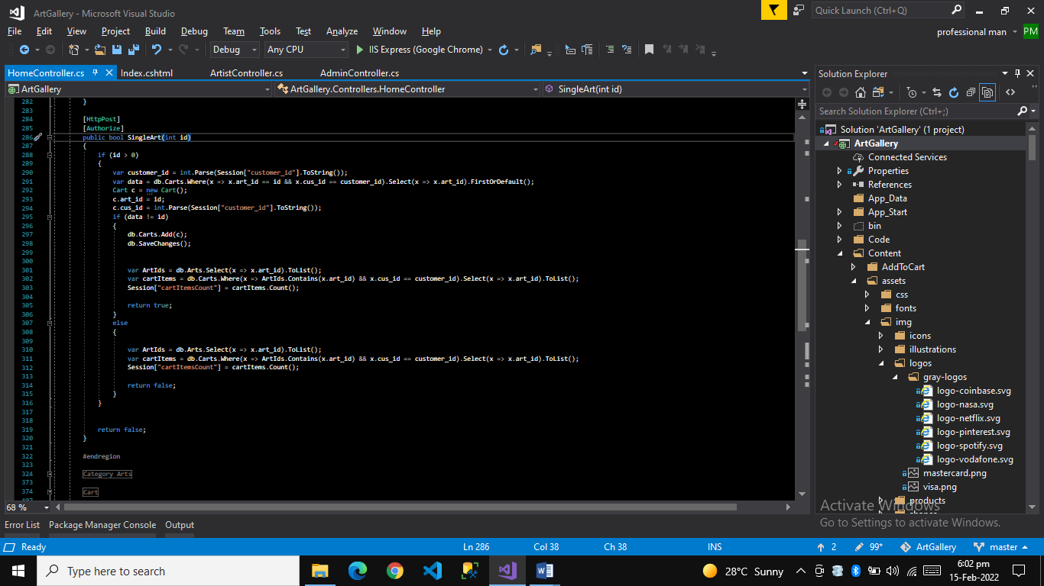

Auction Art Page

Auction art page with bidder can bid easily and auction functionality with ajax page not reload and also add comments functionality with ajax

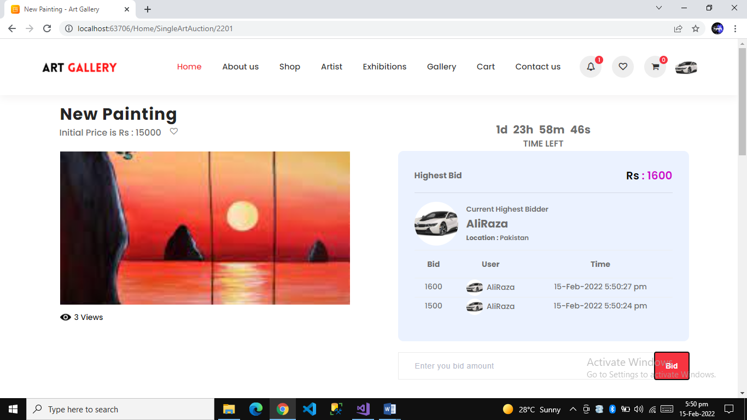

Auction Work Code Images Controller Work

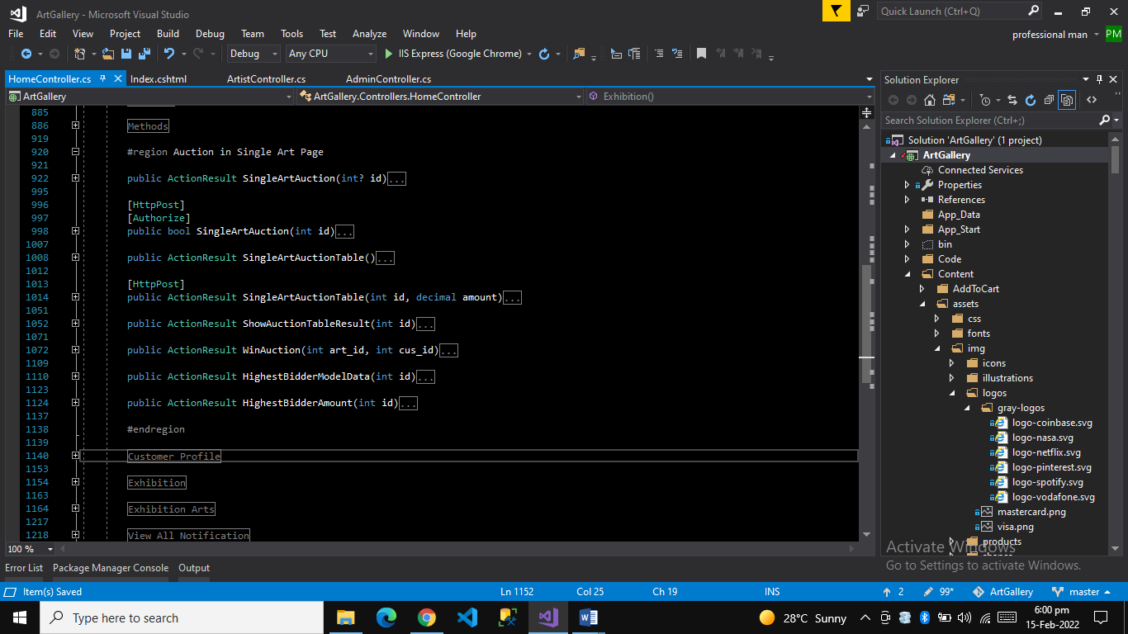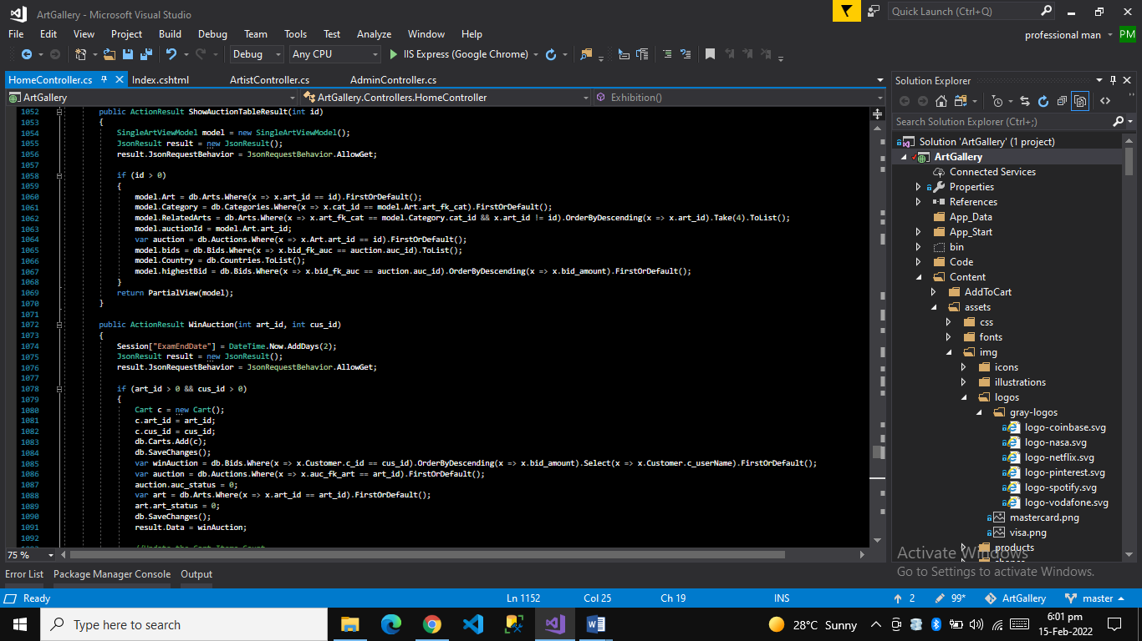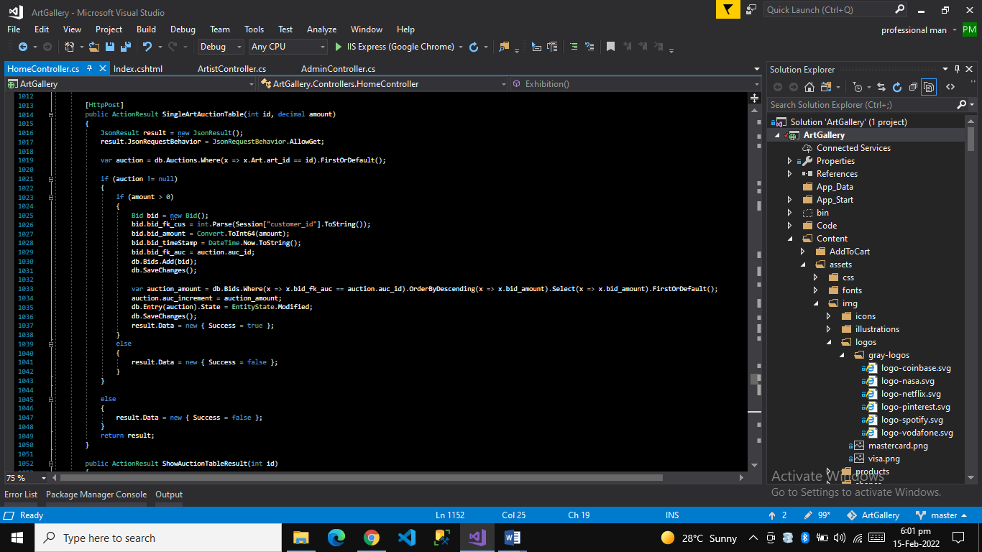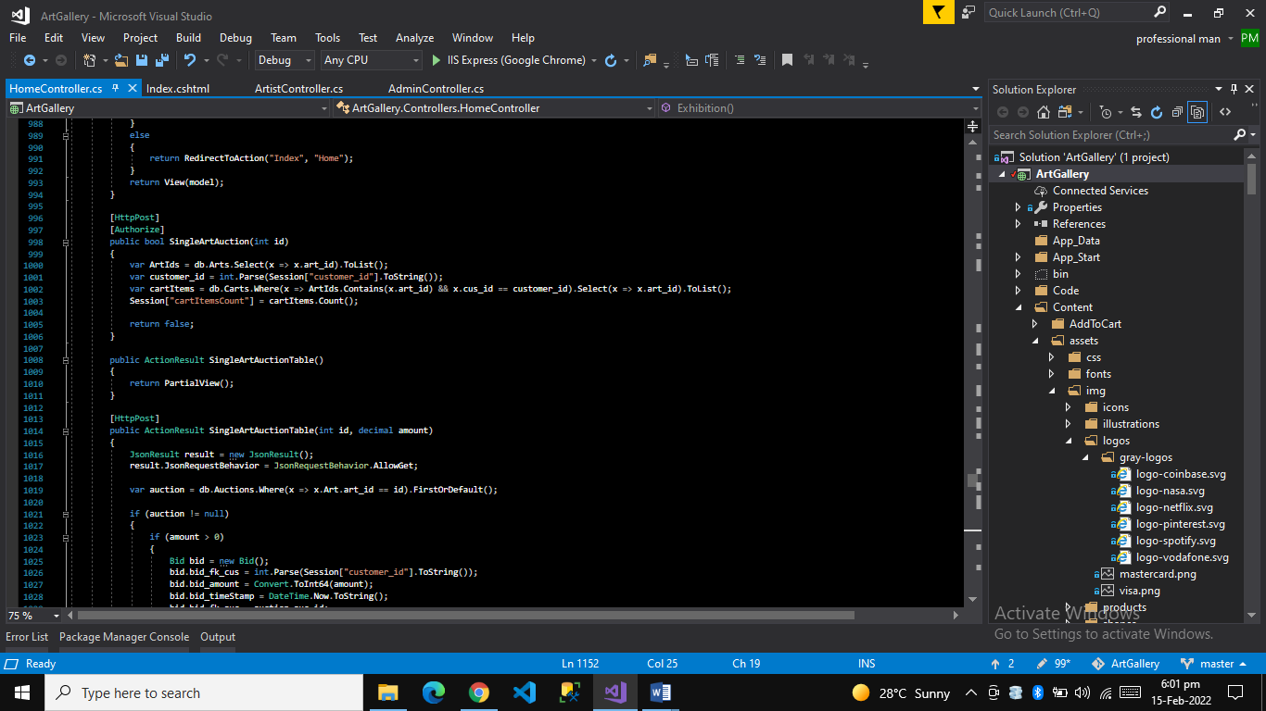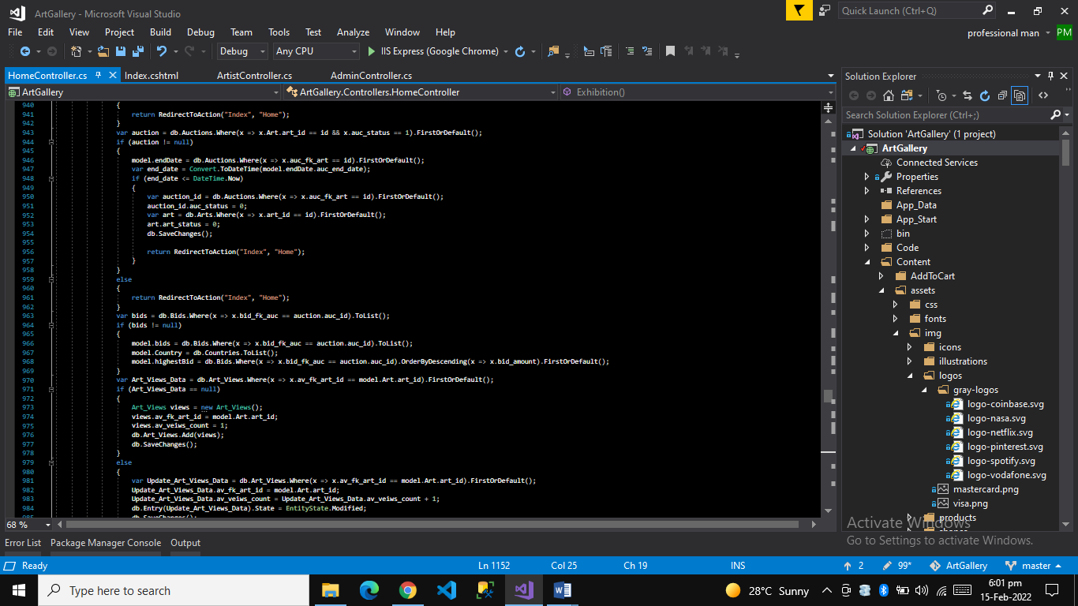

Auction Work Code Images View Work

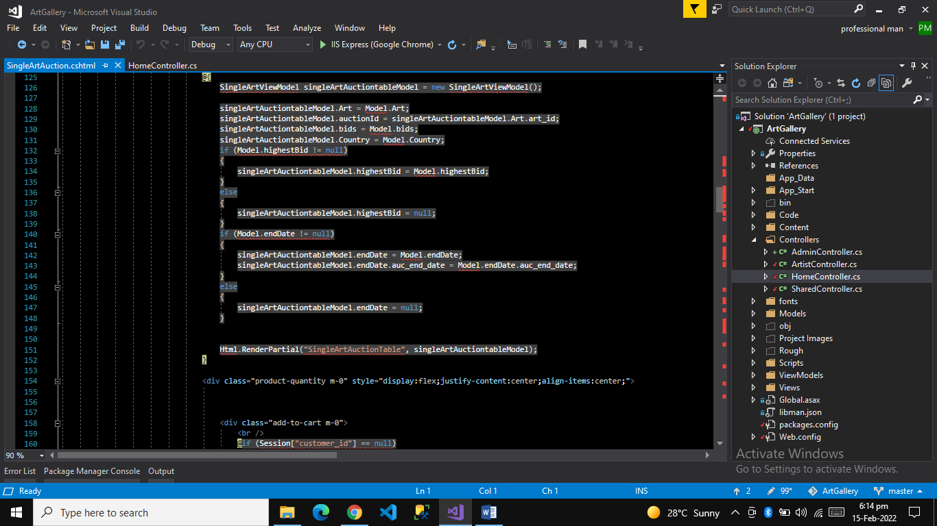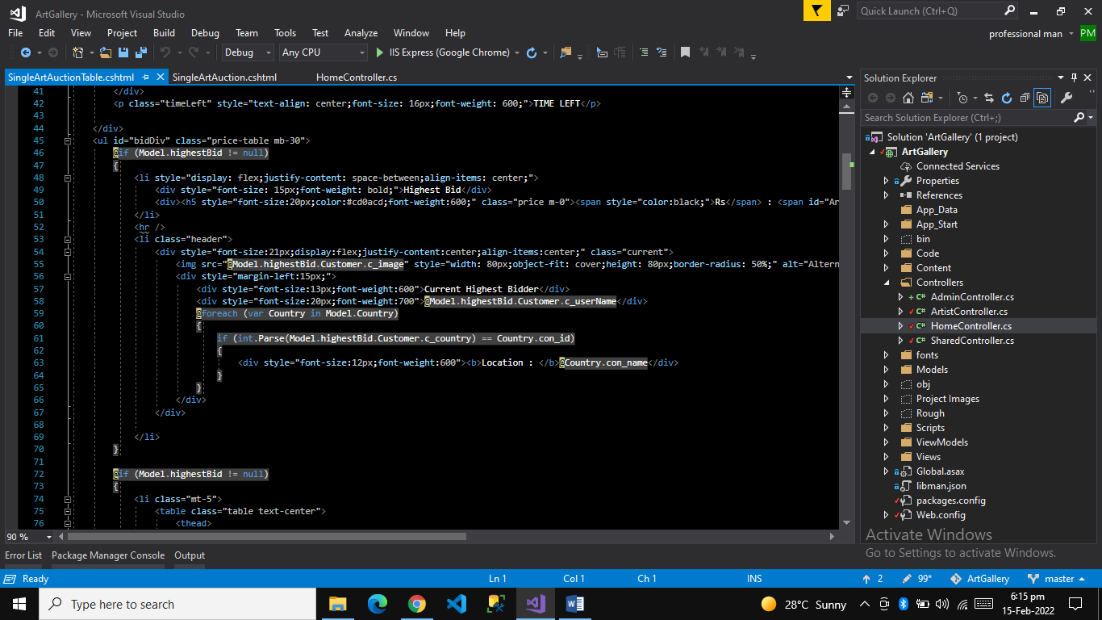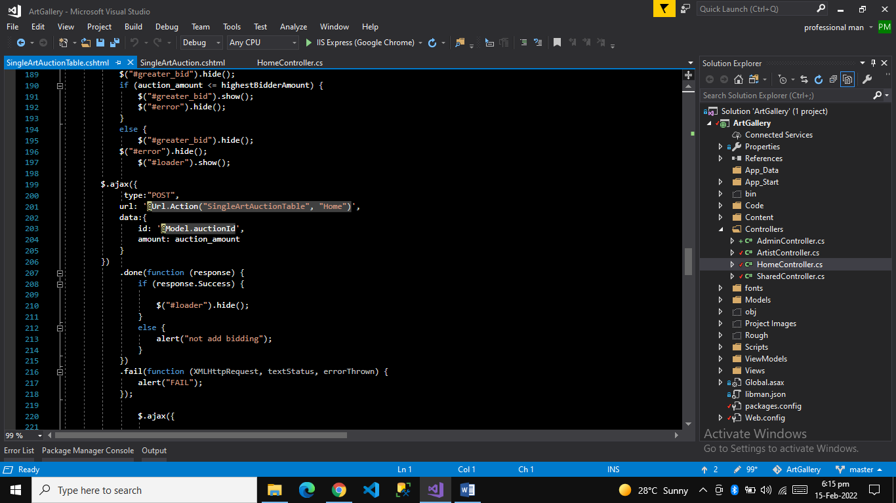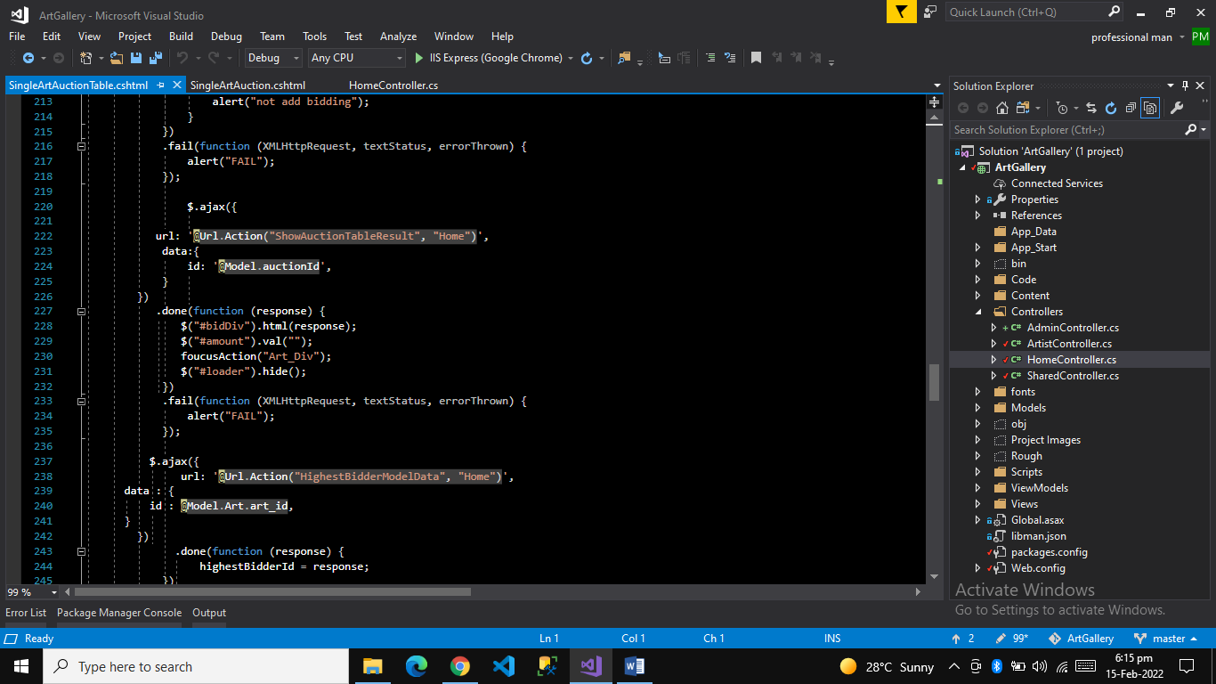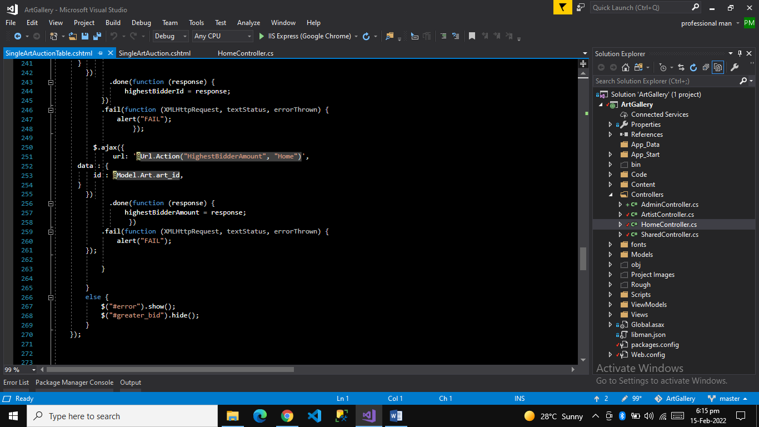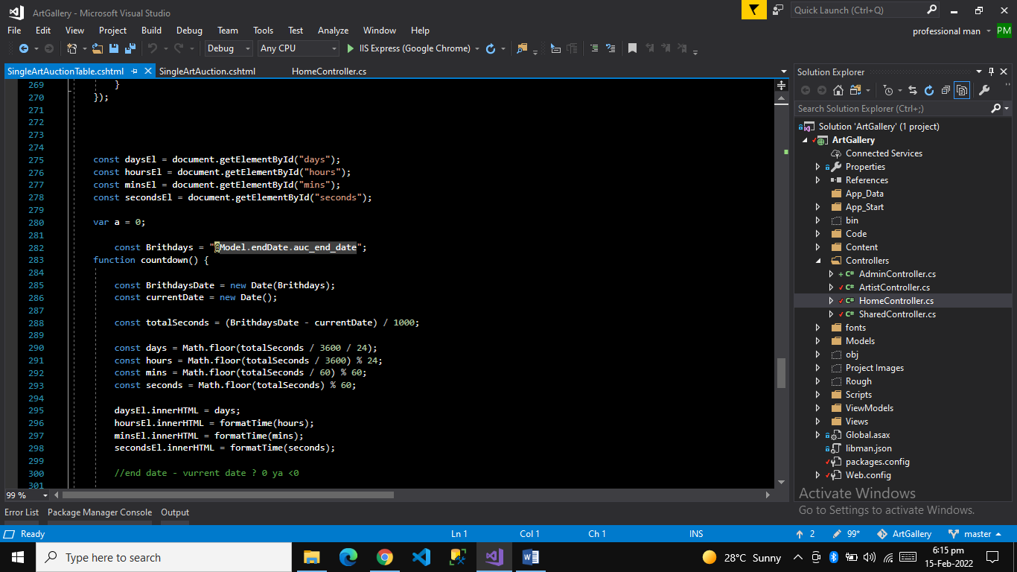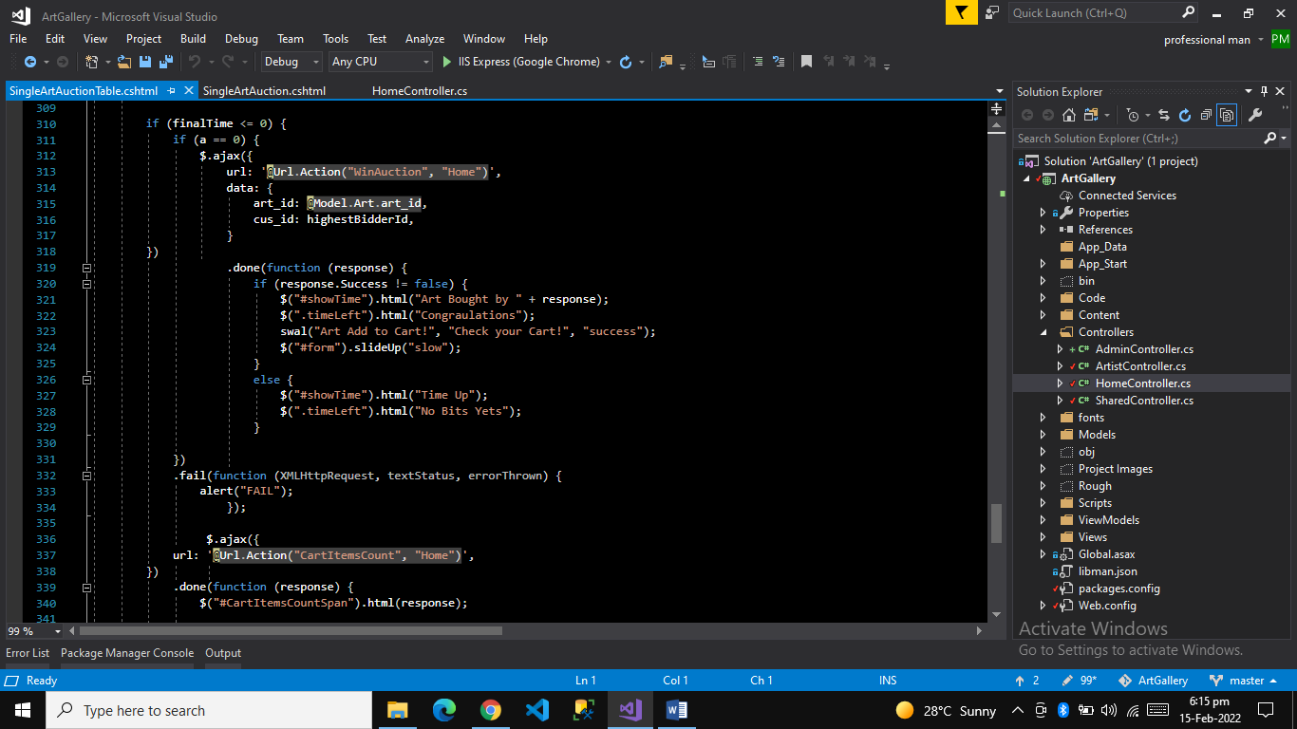

Category Wise Arts Page

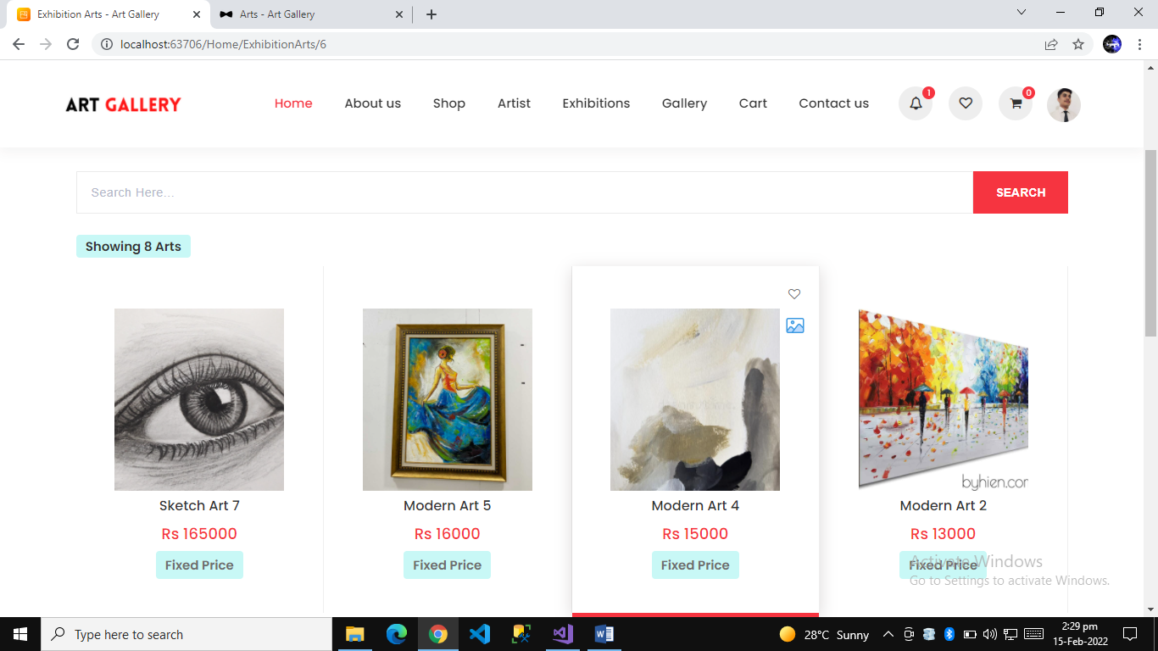

Artist Arts page

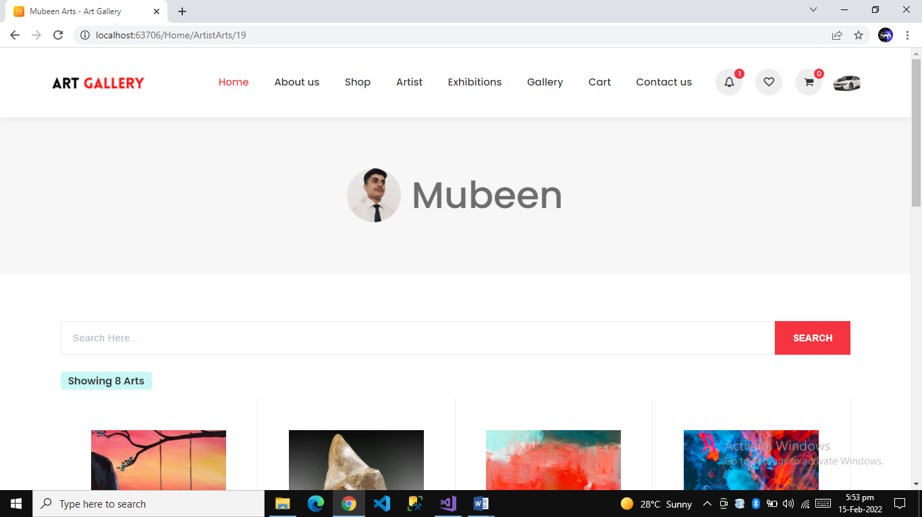

Payment Mode

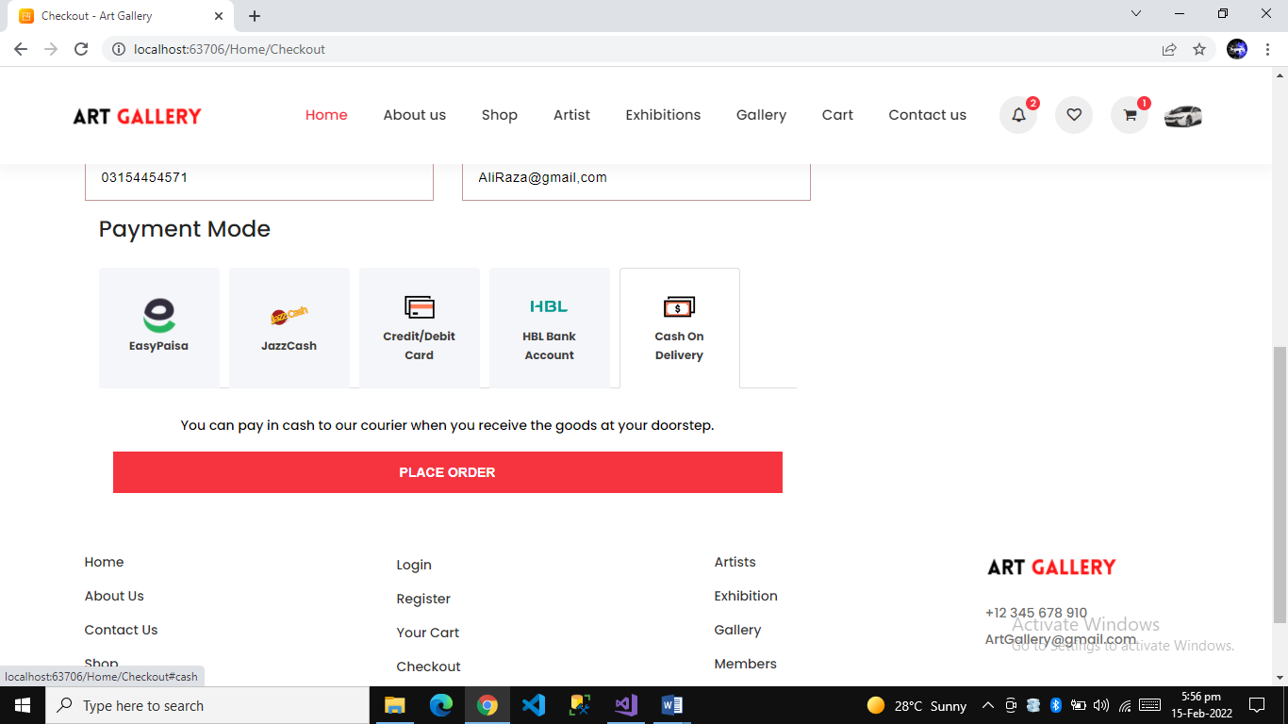

Profile page

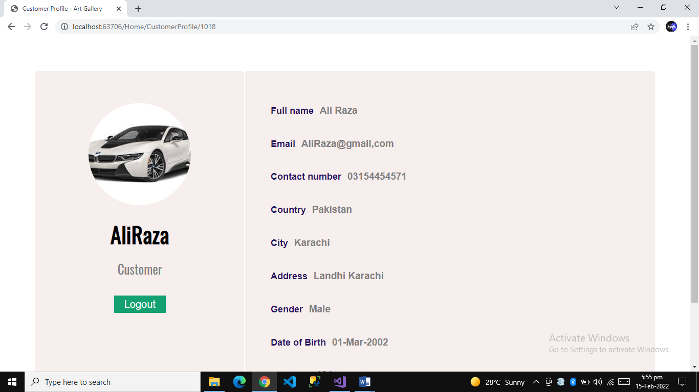

Notificaiton page and Notificaiton section show

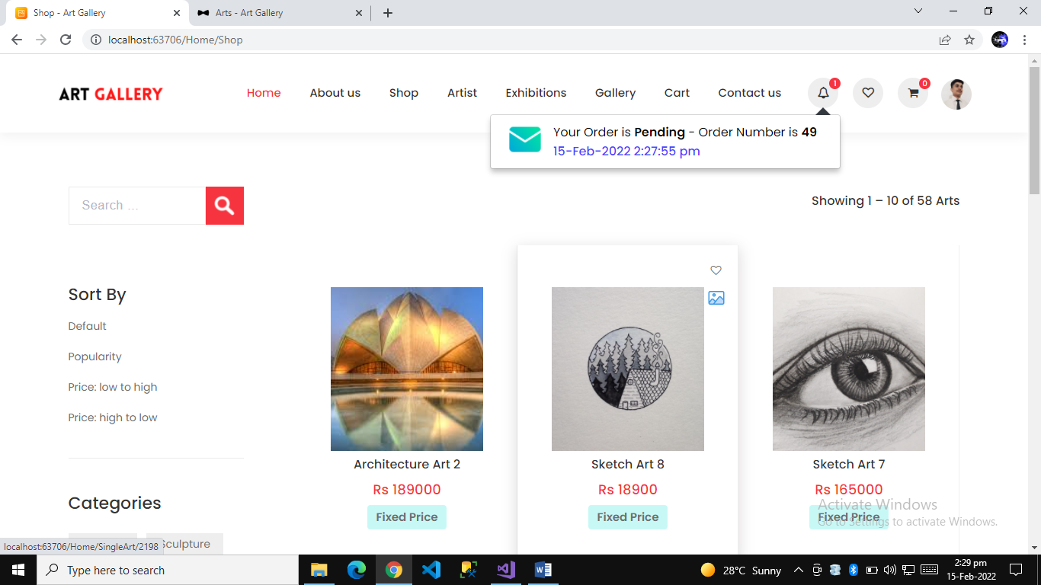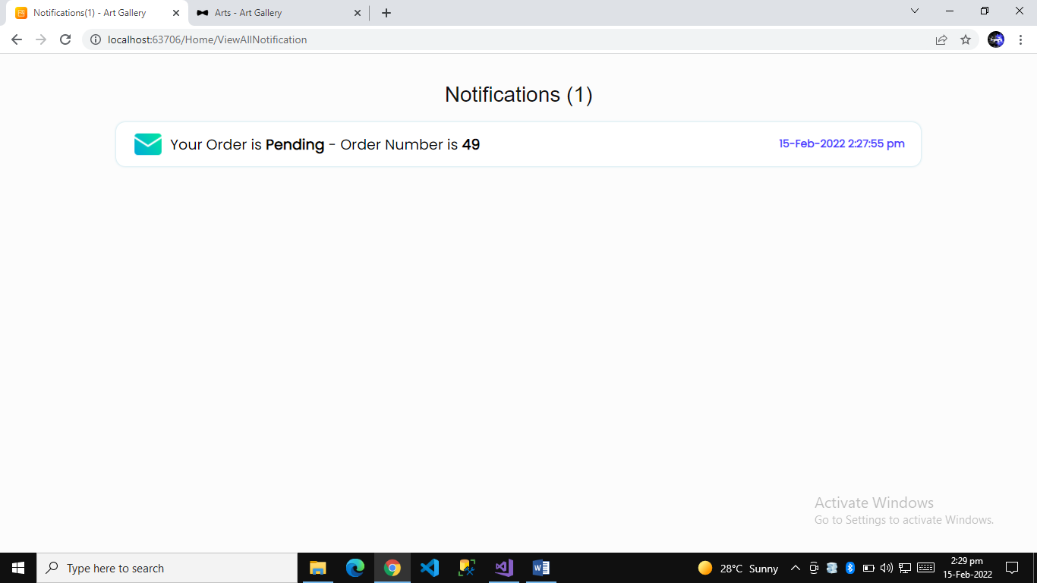

Notification Page Code Image Controller Work

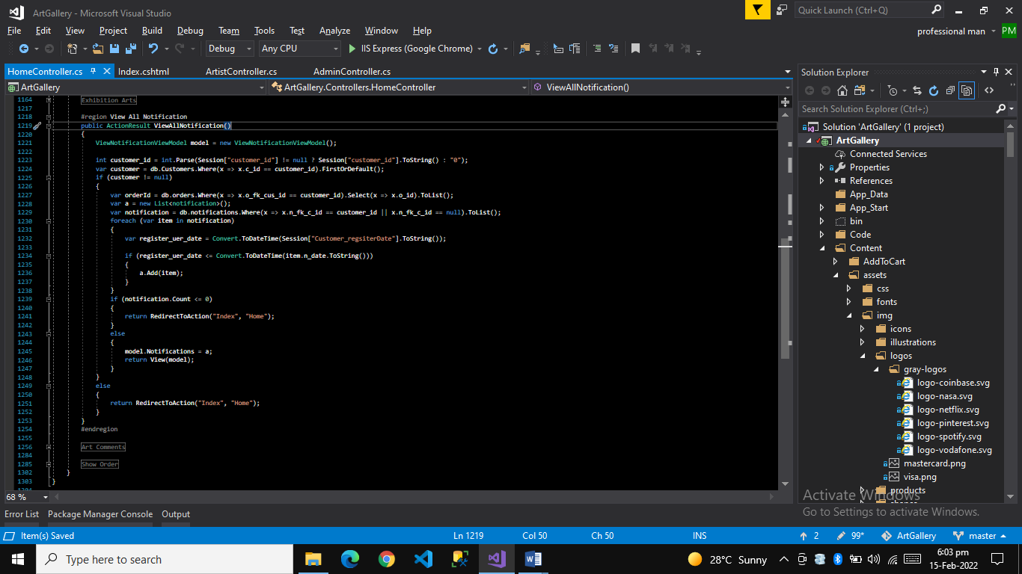

Admin Sign in page

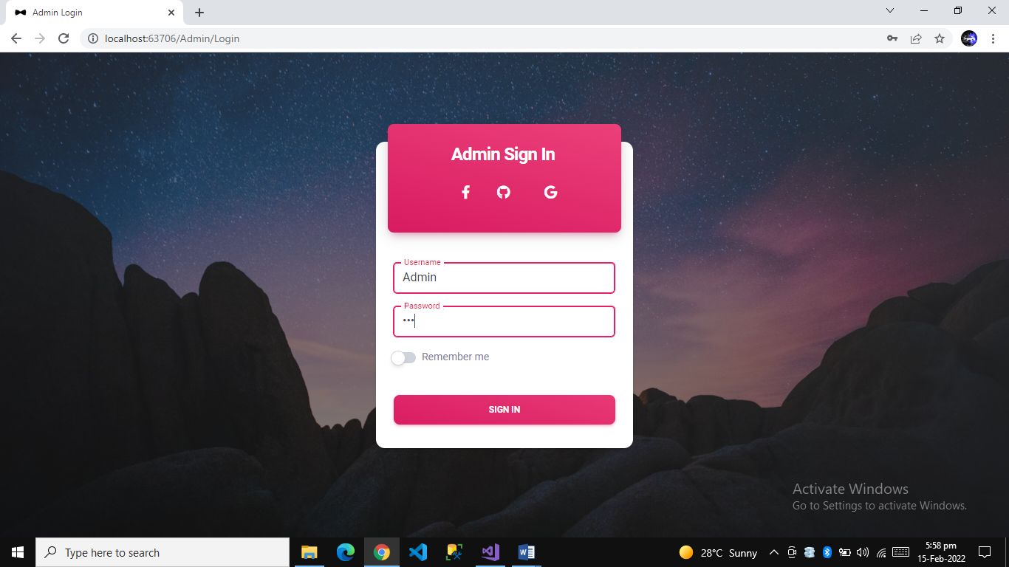

Admin Dashboard page

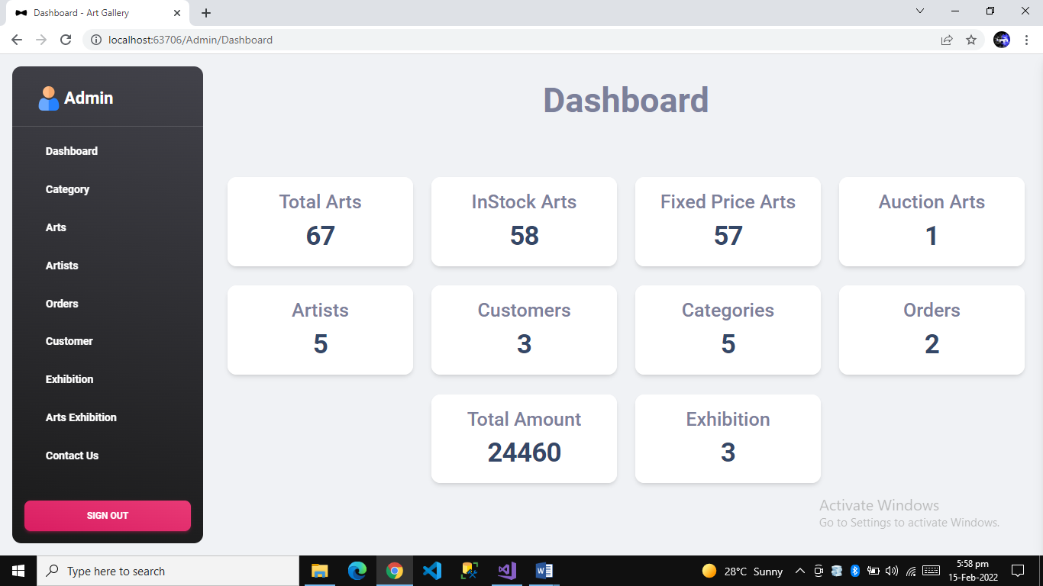

Admin Exhibition Add Images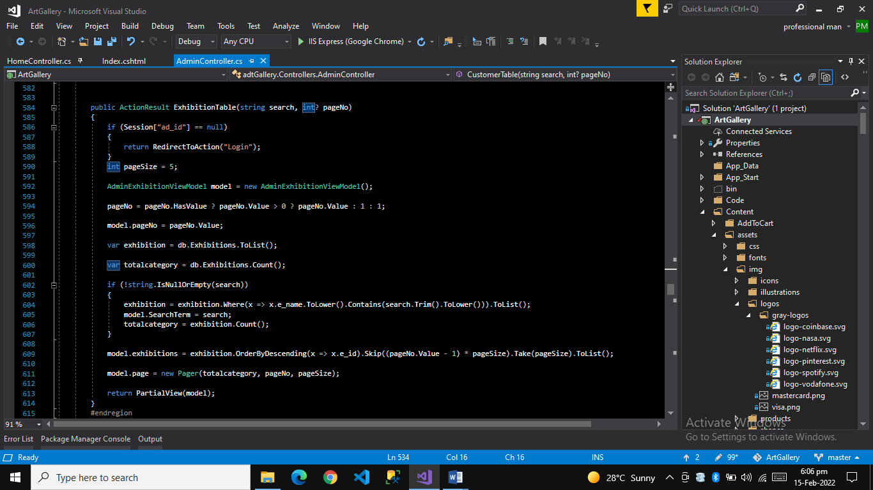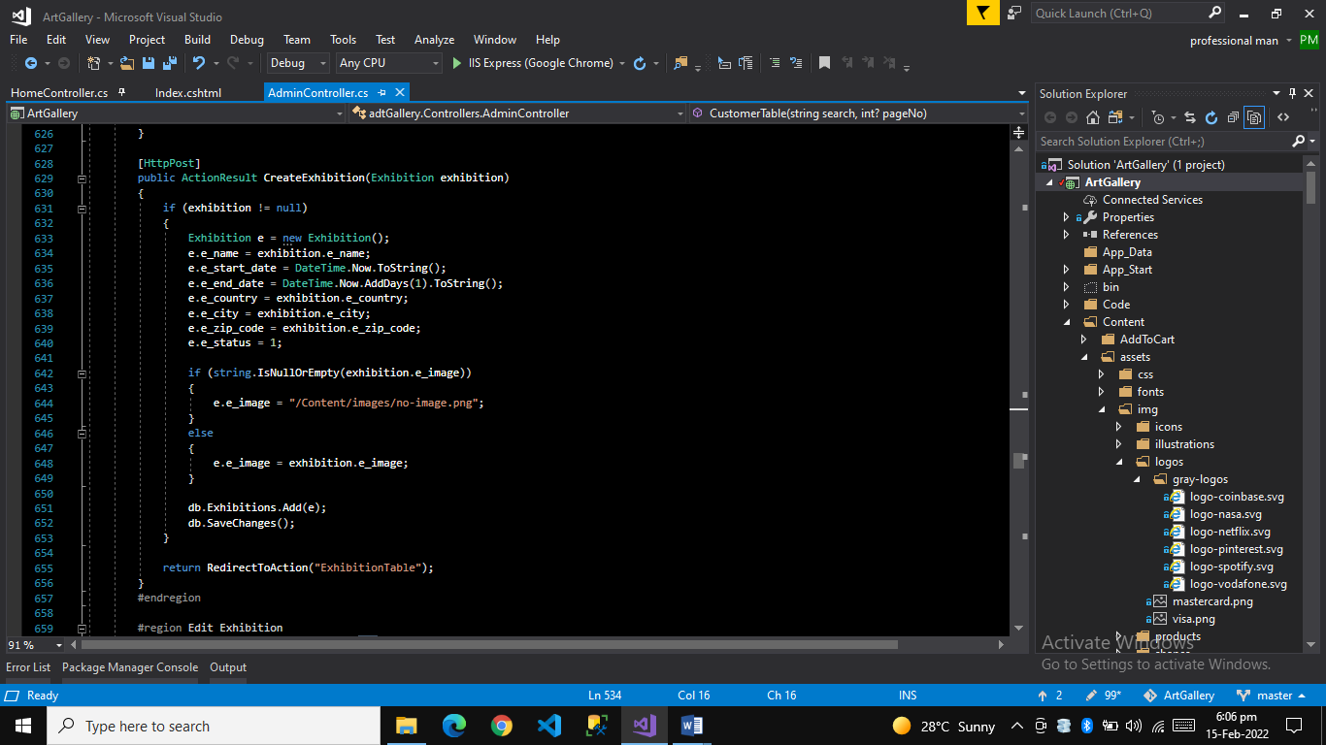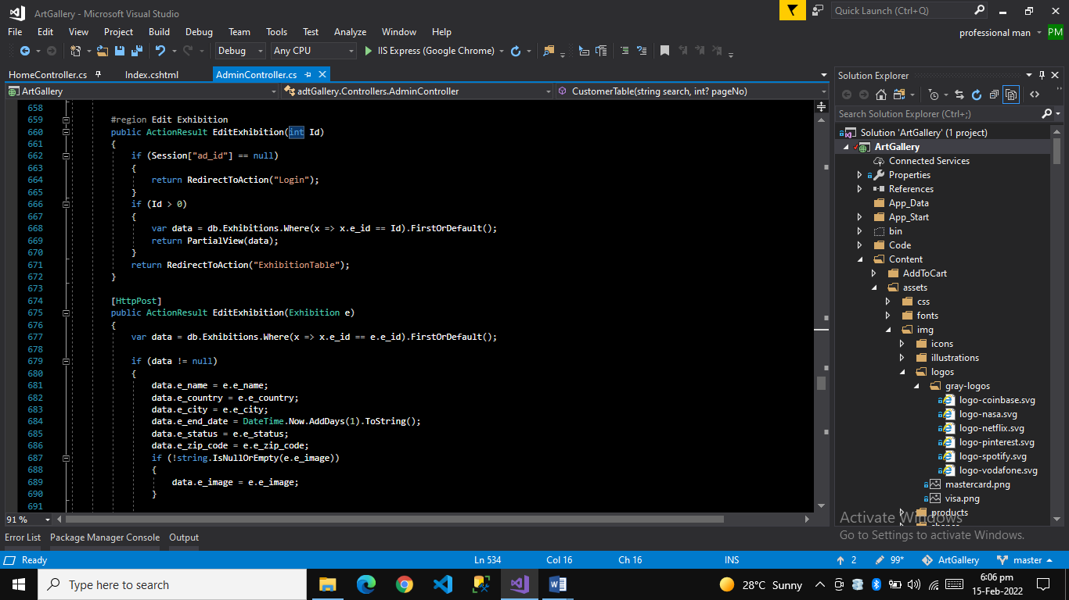

Artist Sign in page

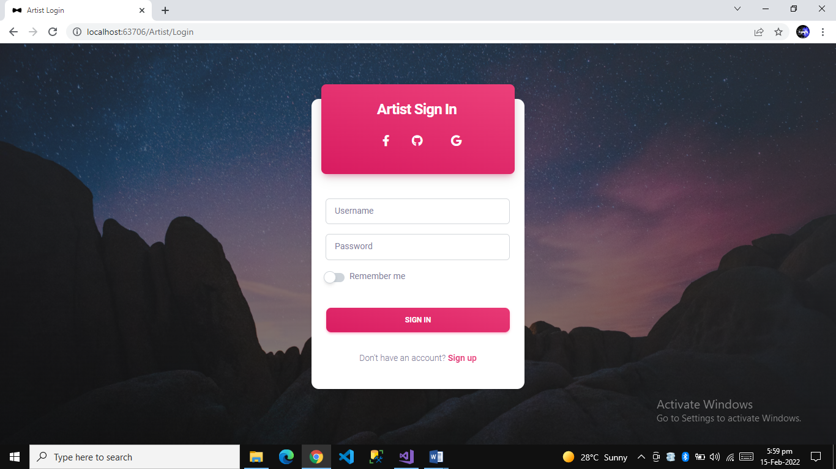

Artist Sign Up page

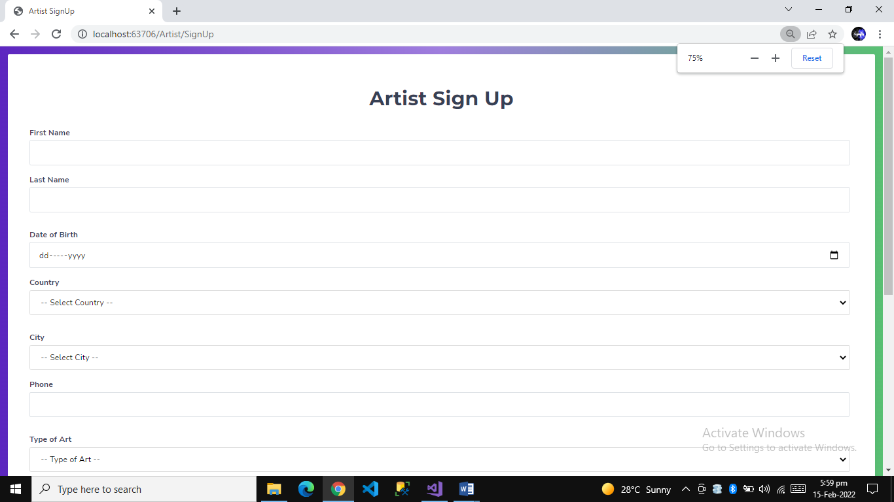

Artist Dashboard page

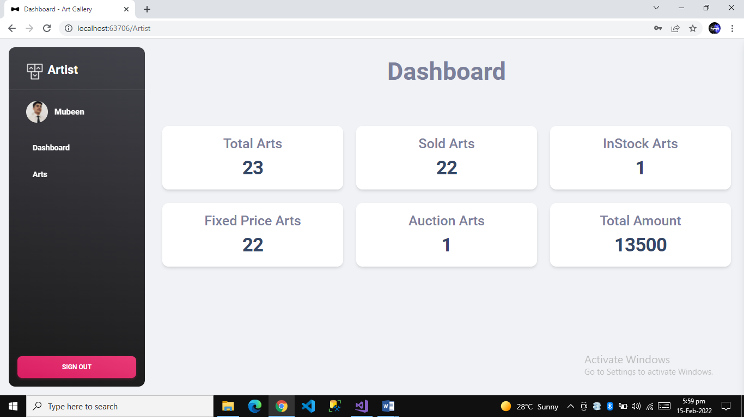

Artist Art work Images

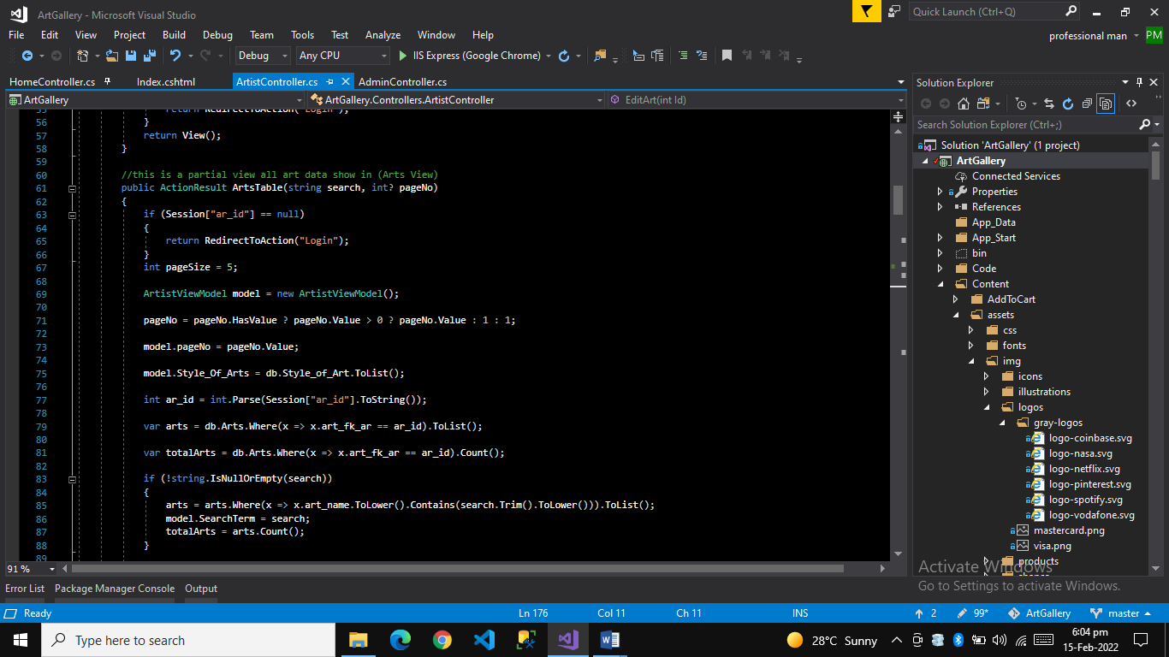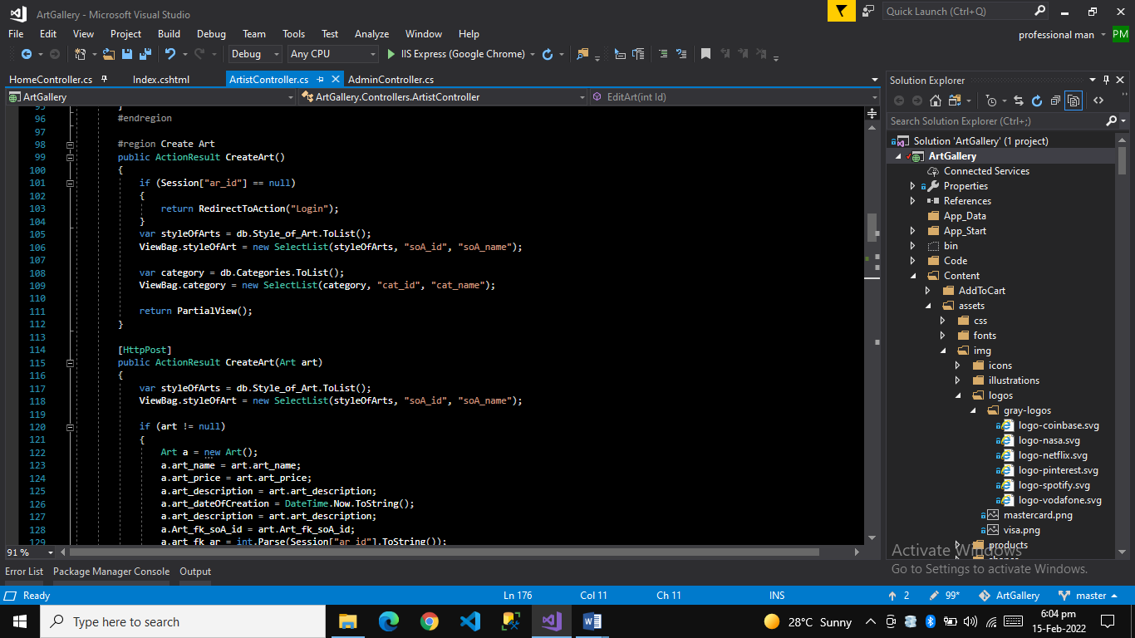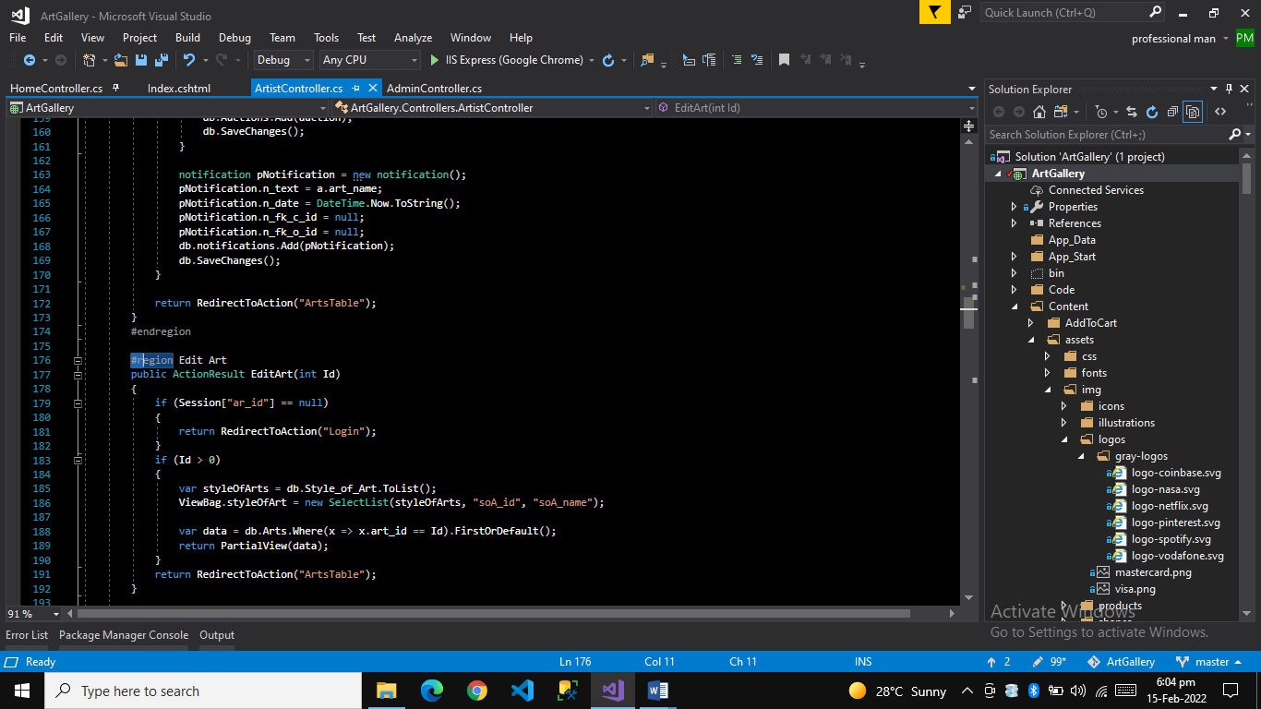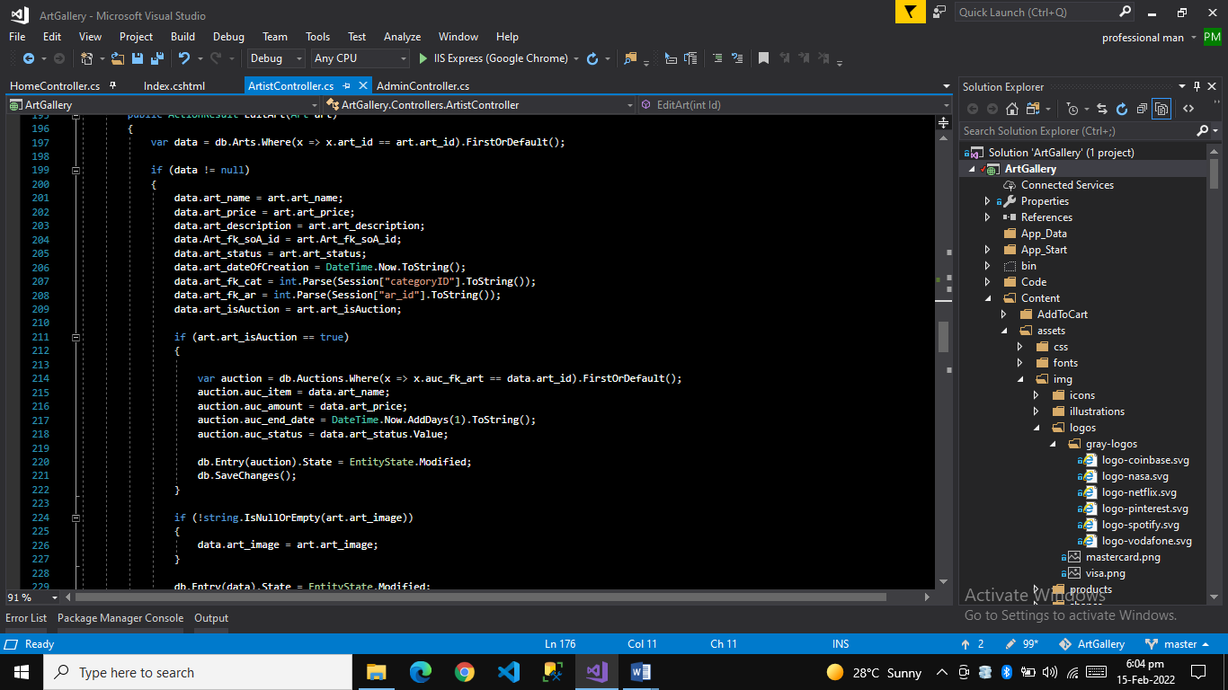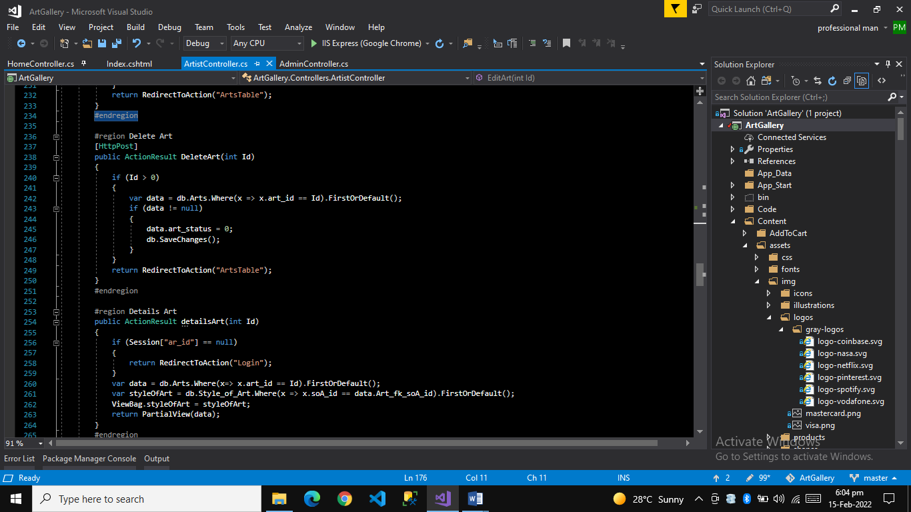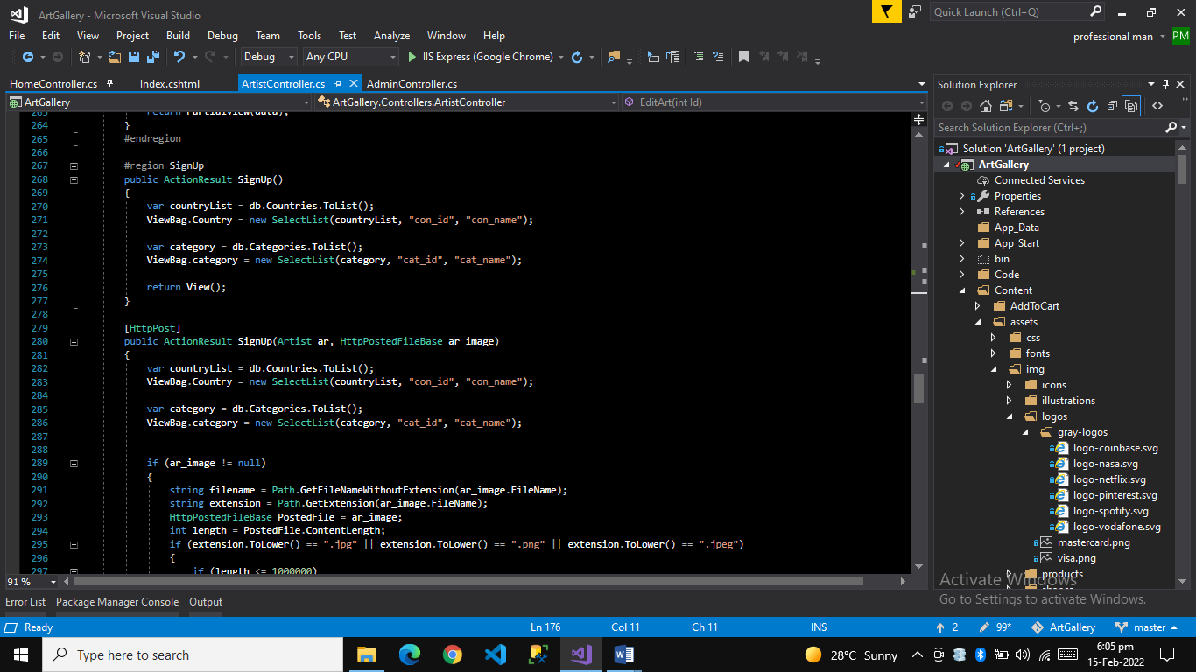

**Error Page**Global Exception Filter

